**WORKBOOK**

**Project Objective:**

**Scenario:**

A city wants to understand household energy usage patterns to design subsidy schemes for energy efficiency. Your task is to analyse household energy data and provide actionable insights.

Dataset:

The dataset contains the following columns:

Column Description

Household_ID Unique identifier for each household

Family Size Number of family members in the household

Monthly_Income Household monthly income

Electricity_Usage (kWh) Monthly electricity consumption

Gas_Usage Monthly gas consumption

Appliances_Count Number of household appliances

Month Month of data recording

**Title**: Household Energy Consumption Analysis

The dataset has been provided Household_Energy.csv

**Step 1: Load Data**

1. Open Excel → **Data** → **Get Data → From Text/CSV**.
2. Select **Household_Energy.csv** → Import.
3. Load into a new sheet.

**Step 2: Clean & Prepare Data**

* Check that columns are properly named:  
  Household_ID | Family_Size | Monthly_Income | Electricity_Usage (kWh) | Gas_Usage | Appliances_Count | Month
* Format numeric columns as **Number (no decimals or 2 decimals)**.
* Ensure Month is consistent (e.g., Jan, Feb, …).

**Create Summary Statistics**

Go to a new sheet → use **PivotTables** for analysis.

**1. Average Electricity & Gas Usage by Family Size-Bar chart**

**2. Monthly electricity vs gas trends-Column chart**

**3. Appliances_Count by Total energy usage-line chart**

**4. Average Energy usage by appliance count-Column chart**

**5. Top-10 total Household Consumption-line chart**

**6. Energy share across income categories-Pie chart**

**7. Family size by Total Energy usage-3D Column chart**

**8.Slicer for Monthly trend**

**9.Slicer for Family size**

**Dashboard:**

This makes it an interactive energy consumption dashboard

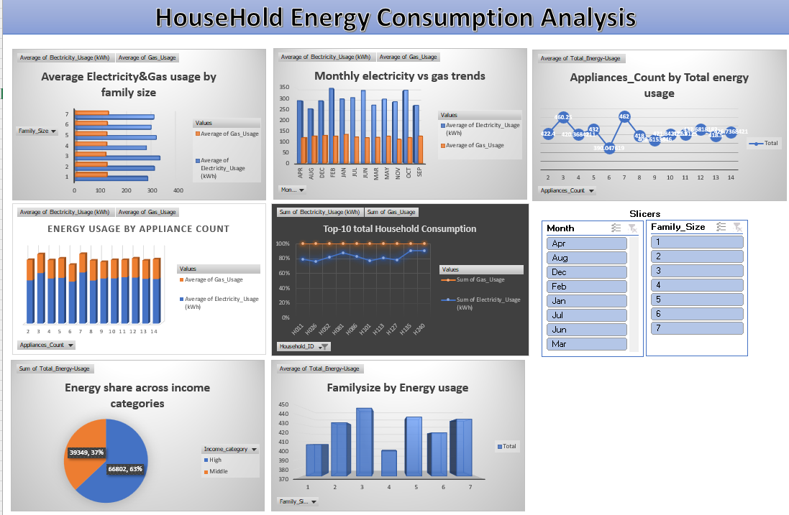

**Summary:**

**Family Size Impact:** Larger families tend to use more gas & electricity.

**Income Effect:** Higher income households generally consume more electricity (appliances, AC, etc.).

**Appliance Effect:** More appliances = higher electricity usage.

**Seasonal Trends:** Electricity peaks in summer (cooling), gas peaks in winter (heating).

**High Consumers:** Identify top 10 households → potential subsidy or efficiency target.